1.0 Scope |  |  |  |  | 2.0 Resource Required
1.1 Purpose: To Temper Glass as per Customer requirement on Flat glass.  1.2 Area of Application: Tempering Line 1  1.3 Responsibility: Shift Tempering Officer  1.4 Accountability: Tempering Production head |  |  |  |  | 2.1 Man: Shift Tempering Officer  2.2 Machine: Tempering Machine  2.3 Material: Grounded Glass/Coated Glass, Cleaning tools,
3.0 Terms and Definition |  |  |  |  | 4.0 Key Performance Requirements
3.1 TPD: Tonnage per day  3.2 SQM: Square meter  3.3 HMI: Human machine interface |  |  |  |  | 4.1 Quality: Glass Should be Fulfilled with All Quality Parameter Regarding Tempering Process like General Bow, Edge Lift, Fragment, mechanical Strength which can make Glass Easy to fit into Solar Module.  - EHS: Dust Pollution, Cut Injuries, burn injury, Noise level
5.0 Frequency |  |  |  |  | 6.0 Training & Communication
5.1 During production and when required as per the production planning |  |  |  |  | 6.1 Training on Tempering Machine Operation to be Given To all Shift Officer.  6.2 Visual posters are to be used for Do’s & Don’ts & communication.
7.0 Procedure
  - Sequence of Operation

7.1.1 Start procedure
- Check first there is not any object inside furnace before down the furnace.
- Check all rollers are moving in same direction (forward).
7.1.2 To start heating
- On the Heating breaker and check indication on light.
- Set firing at 1 point all heater with temperature 680 degree of all.
- On the heating from panel heating switch, observe load >0.6MW
- When temperature reached approx. 700 degrees Celsius, load parameter from recipe folder
7.1.3 To start blower
- Set frequency at 20% first.
- Start blower one by one.
- Increase frequency by 20%, 40%, 80% and 100% maximum.
- Check all Kevlar roller moving in forward direction of quenching, cooling and unloading section.
- Set quenching and cooling nozzle position.
7.1.4 Trial and setup
- Take Dummy trail to ensure all sensors and roller working in good condition also ensure packing side.
- Take rejection glass trail to set parameters and to ensure glass quality.
7.1.5 Emergency conditions when glass jam
- Stop the heating.
- Decrease the blower frequency at 10%.
- Off Heating Breaker switch.
- Uplift the furnace and quench section to clear the glass.
- After cleaning check ceramic roller condition.
- Clean ceramic roller.
- Down the furnace.

7.1.6 The following details should be checked before operating the machine.
- Check all the surrounding boundaries of the Tempering Machine. Turn on the Power from the Main panel after receiving approval from the Electrical department. |  |  |  |  |  | 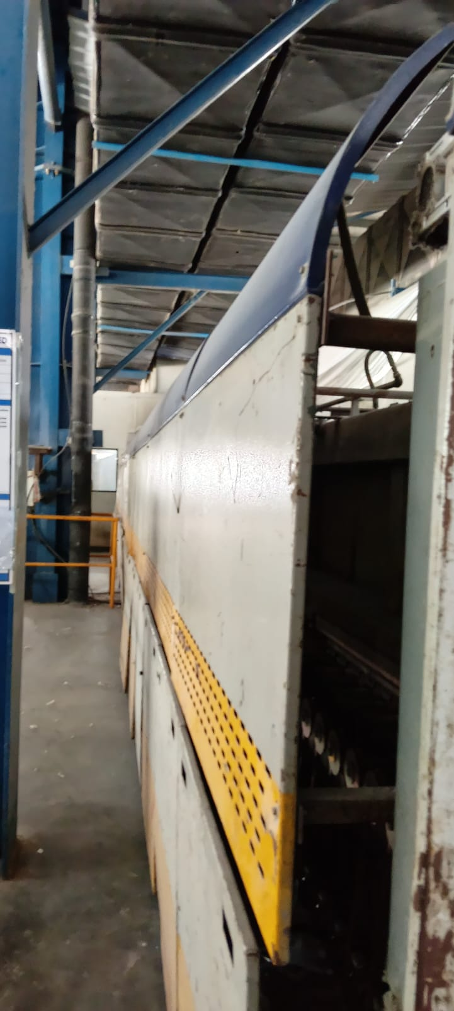
- Turn on the Power from the Main panel after receiving approval from the Electrical department. |  |  |  |  |  | 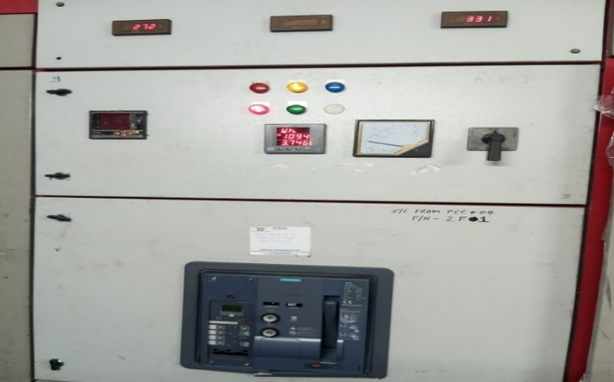
- Check Ceramic Roller Driving Belt Should be properly fit on Driven Shaft & Pulley. |  |  |  |  |  | 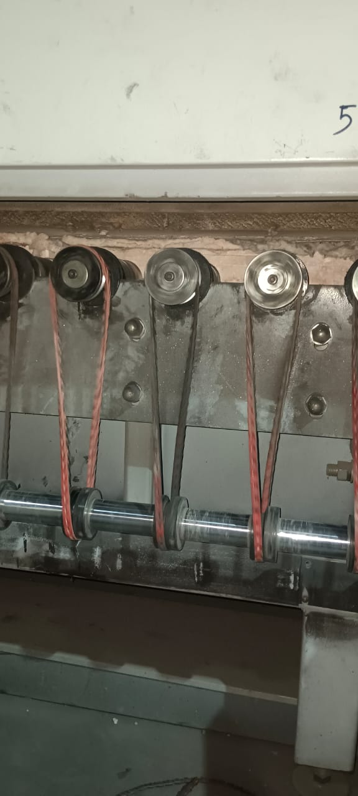
- Check the Quenching & Cooling Kevlar Roller Conditions.  Note: If Roller Rope is found damaged Condition, then Replace it. |  |  |  |  |  | 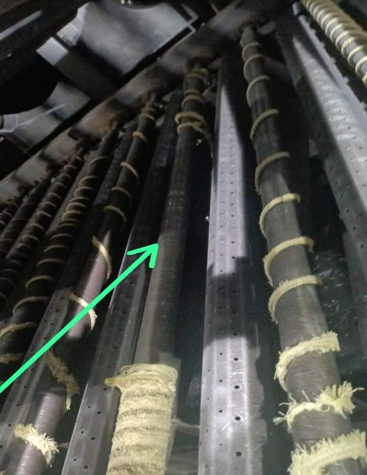
- Close both Quenching & Cooling Section from Control Panel. |  |  |  |  |  | 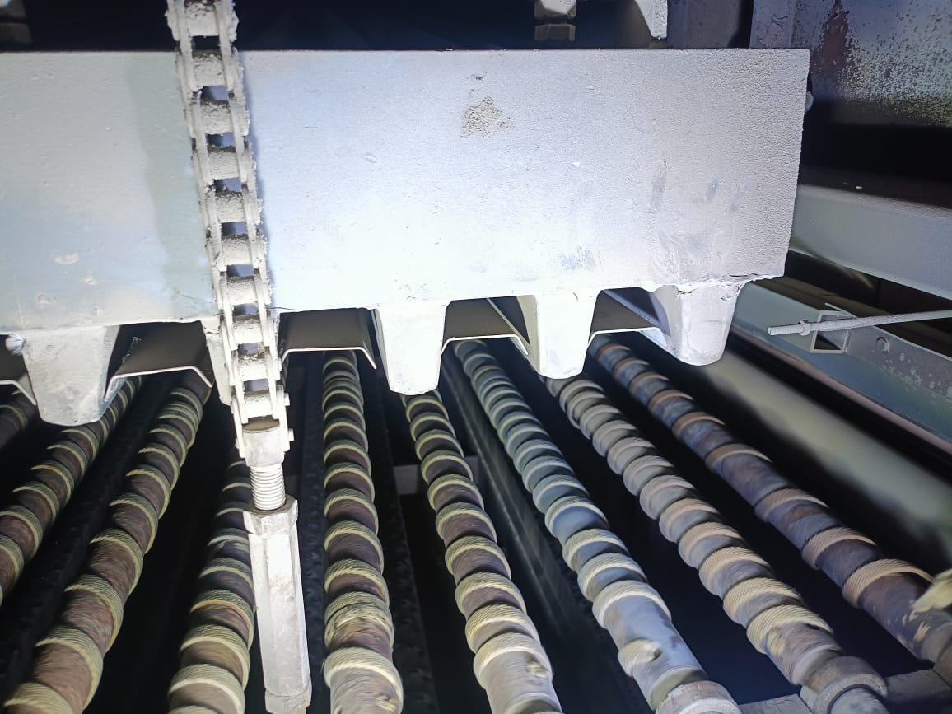  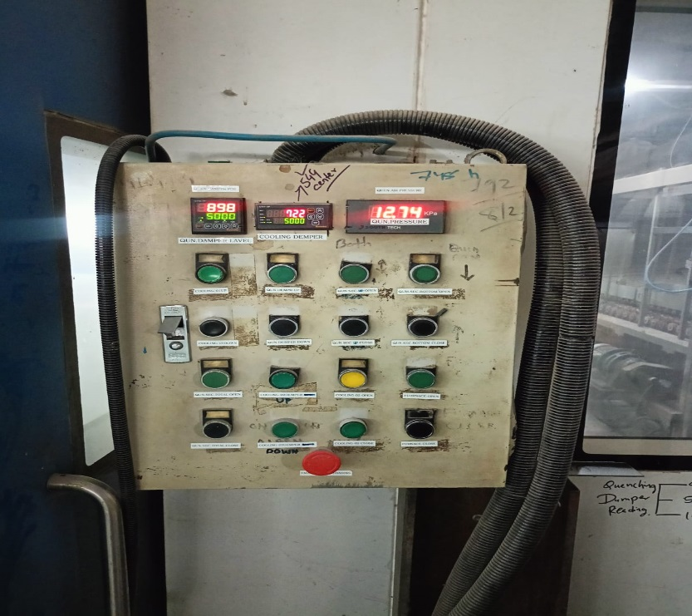
- Start Furnace, Quenching & Cooling Roller Drives from Main Panel. |  |  |  |  |  | 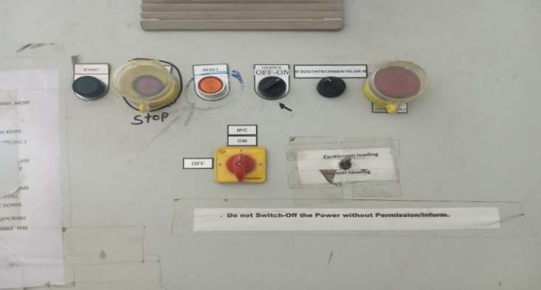  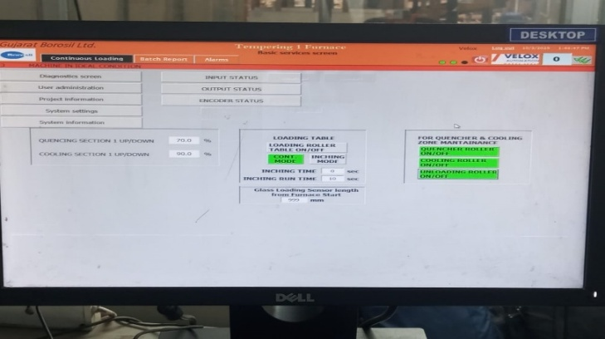
- Check Ceramic Roller Rotate in Same Forward Direction. |  |  |  |  |  | 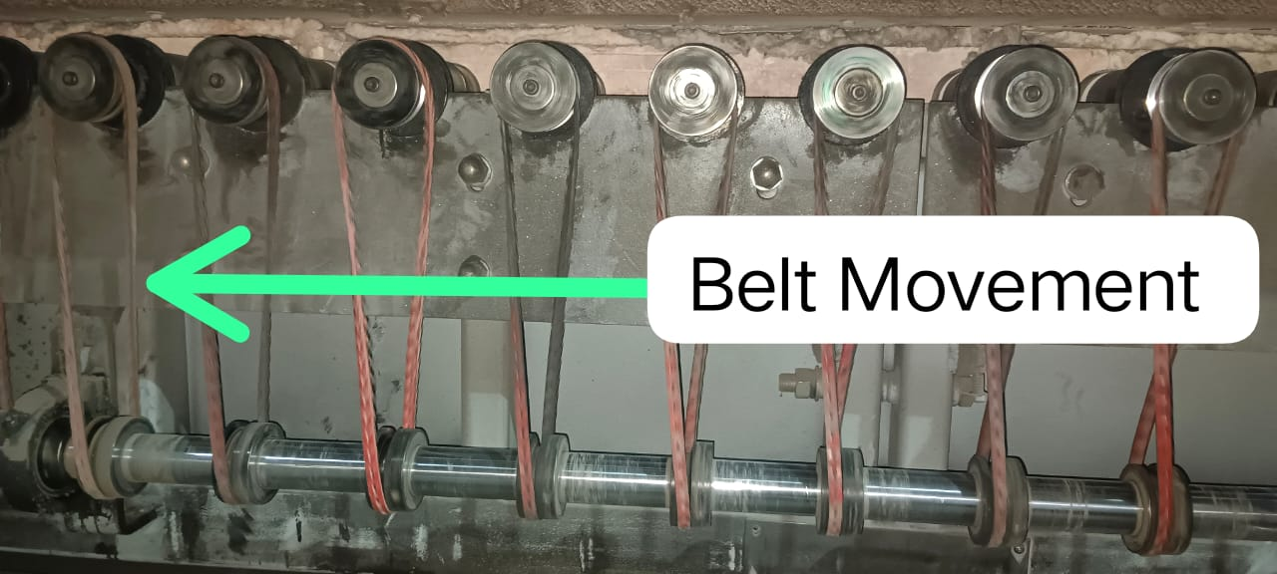
7.1.7 Now Start Furnace Heating with Firing rate of 1 point. (Firing rate is in 1 to 10)
- First zone (Top) |  |  |  |  |  | 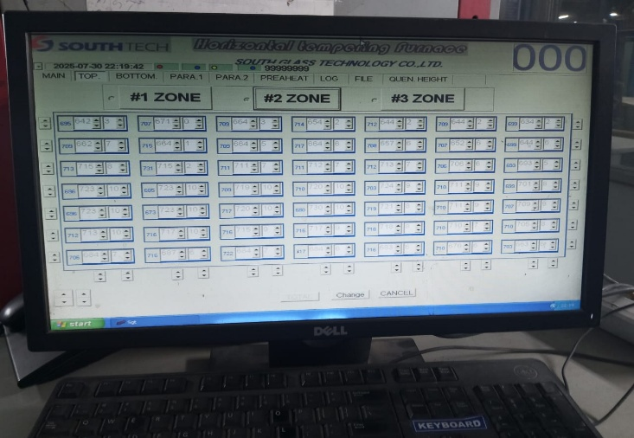
- First zone (Bottom) |  |  |  |  |  | 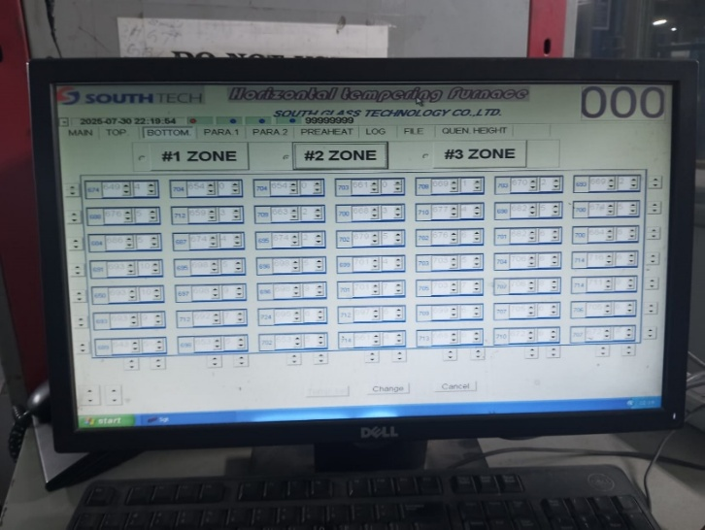
7.1.8 With Increasing of Temperature in all Zones firing Rate also increase manually as per 1 to 10 points as recipe for glass thickness and size.
- Second Zone (Top) |  |  |  |  |  | 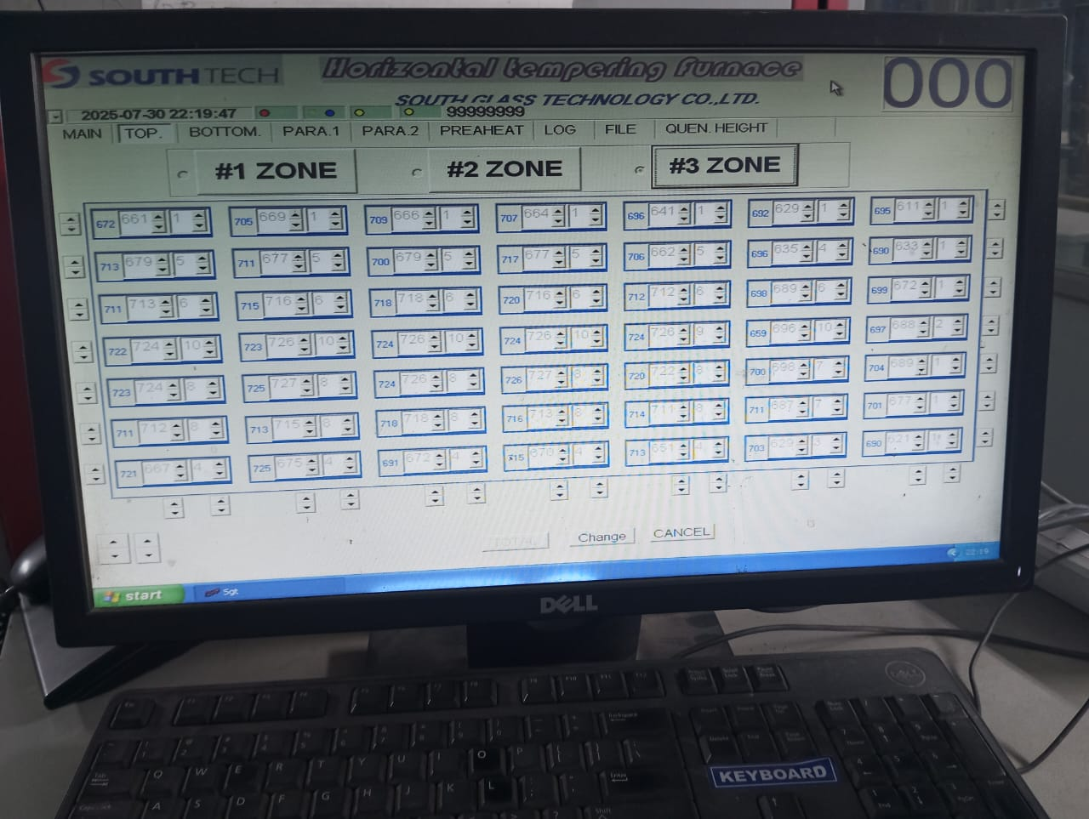
- Second Zone (Bottom)  Note : treat zone naming as mentioned below:  - Zone 1 is Zone 0  - Zone 2 is Zone 1  - Zone 3 is Zone 2  All these are as per electrical department heater wise location  - In Zone 0, only seven heater avaliable in both top and botto each. |  |  |  |  |  | 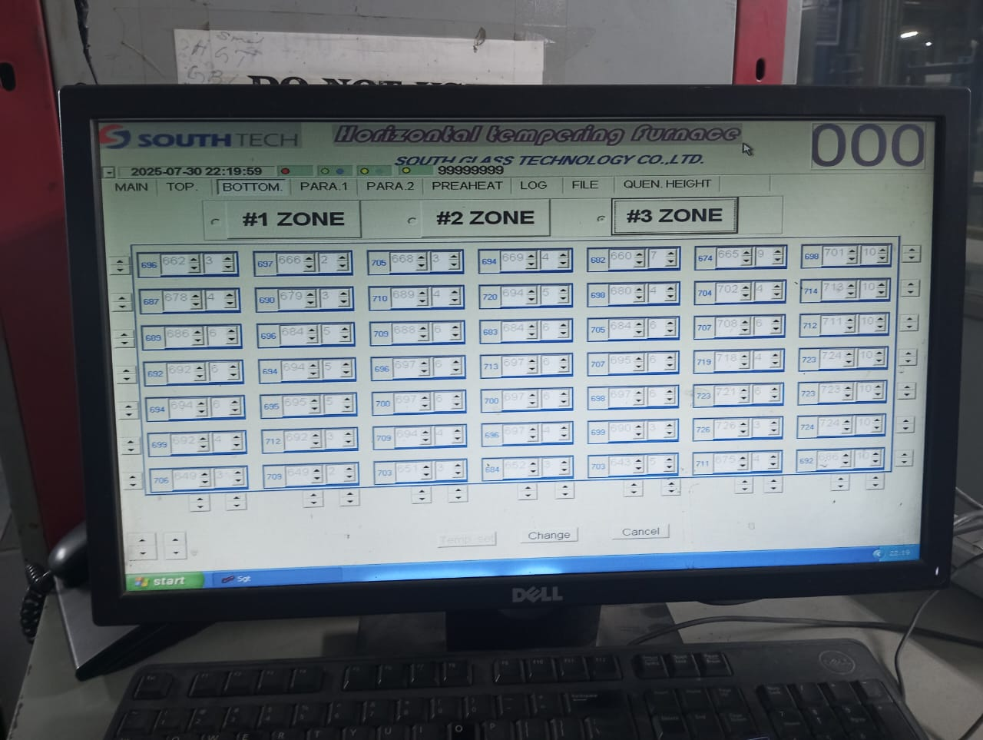
7.1.9 Now Start All of Blower from Control Panel
- First start the blower 2 & 4. |  |  |  |  |  | 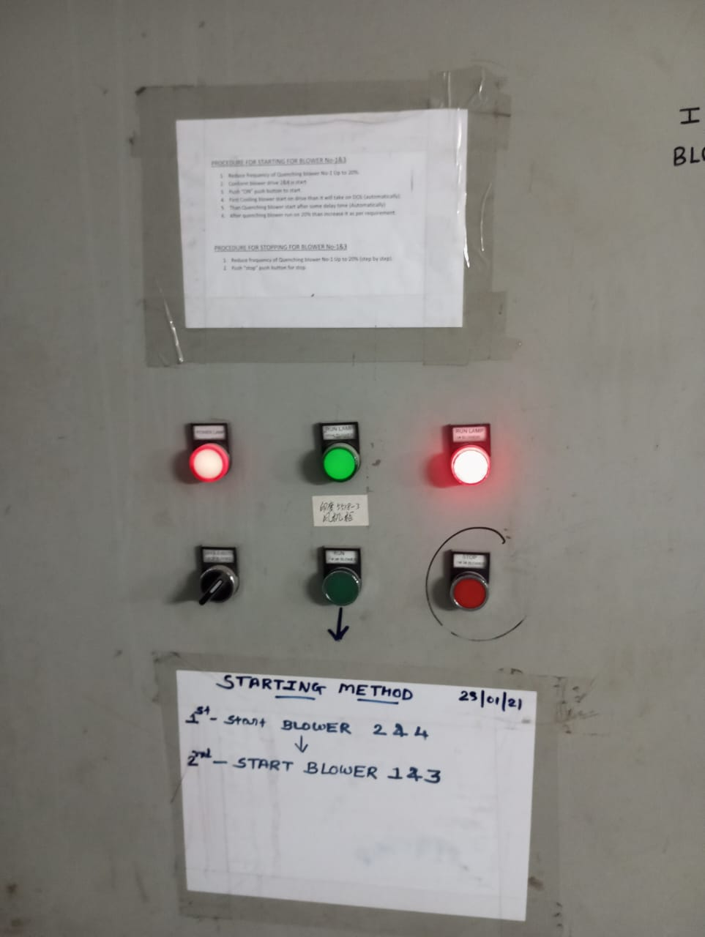
- Then start Blower 1 & 3. |  |  |  |  |  | 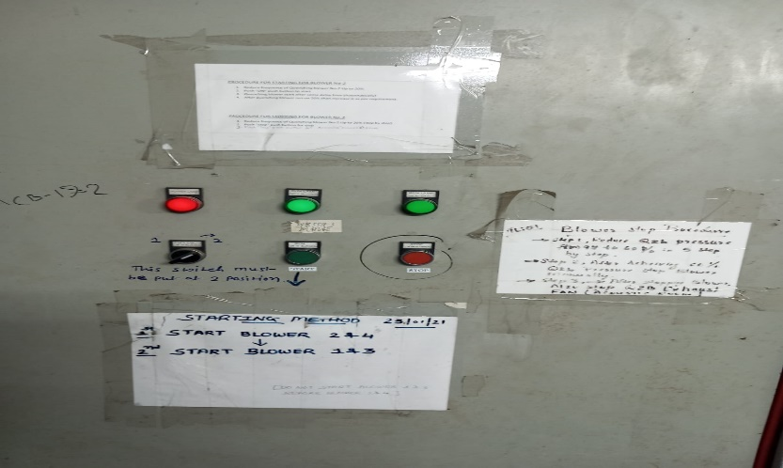
7.1.10 South-tech system to control operation and process parameter. |  |  |  |  |  | 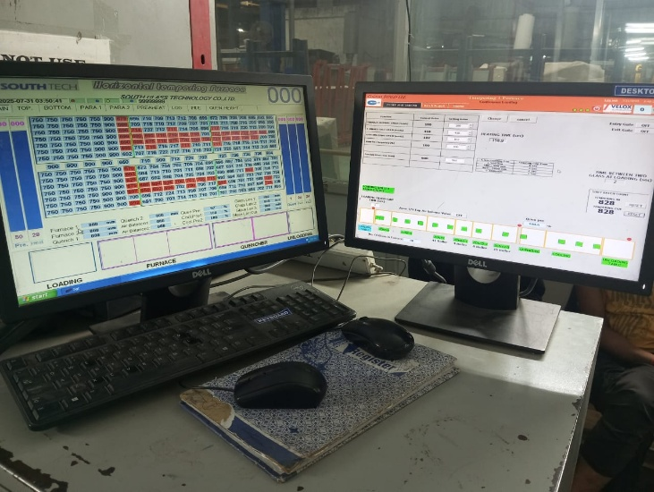
7.1.11 Now, Take Dummy Trial with Sensing inlet Sensor.  NOTE: - In Dummy Trial We Must Check Blower Increasing as per Blower Frequency Speed Set point, Glass Furnace In & Out Time is Proper or Not.  If All Found OK in Dummy Trial, then take a Trial with actual Glass. |  |  |  |  |  | 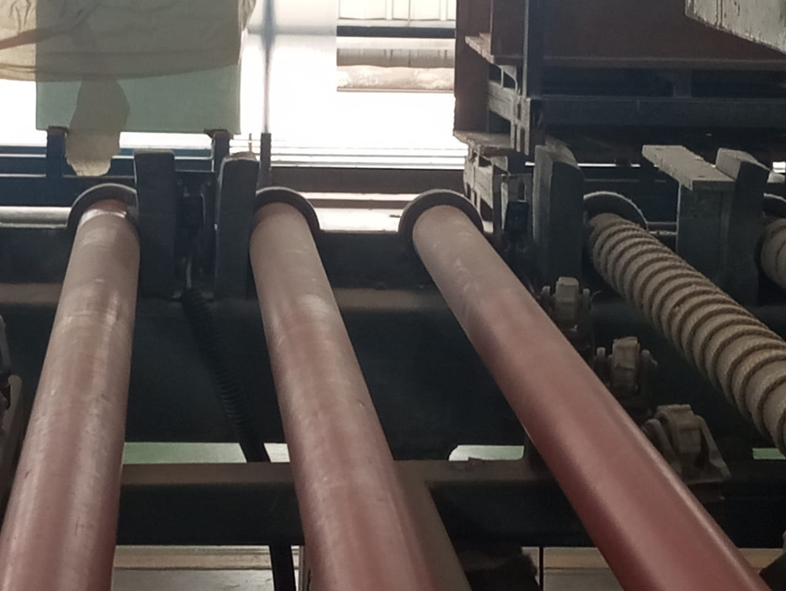  Inlet Sensor
7.1.12 Quality parameters check.
- General Bow Check |  |  |  |  |  | 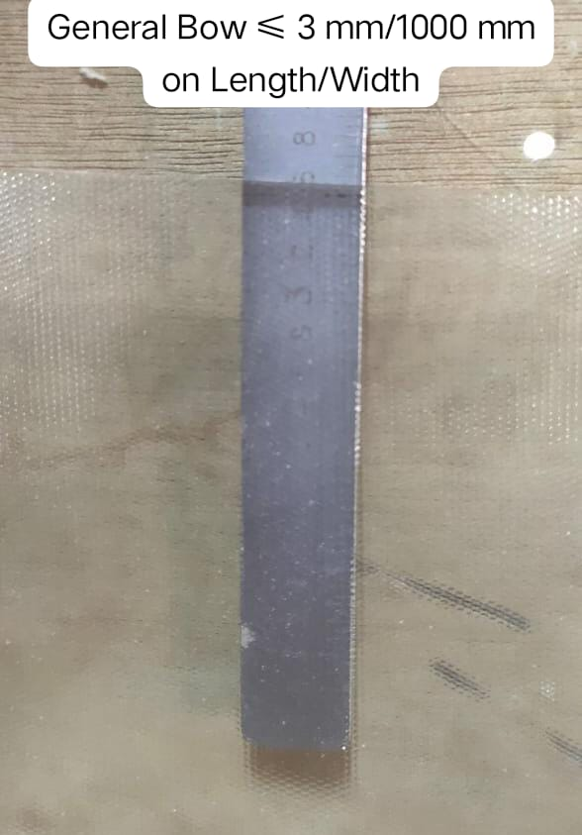
- Edge Lift Check |  |  |  |  |  | 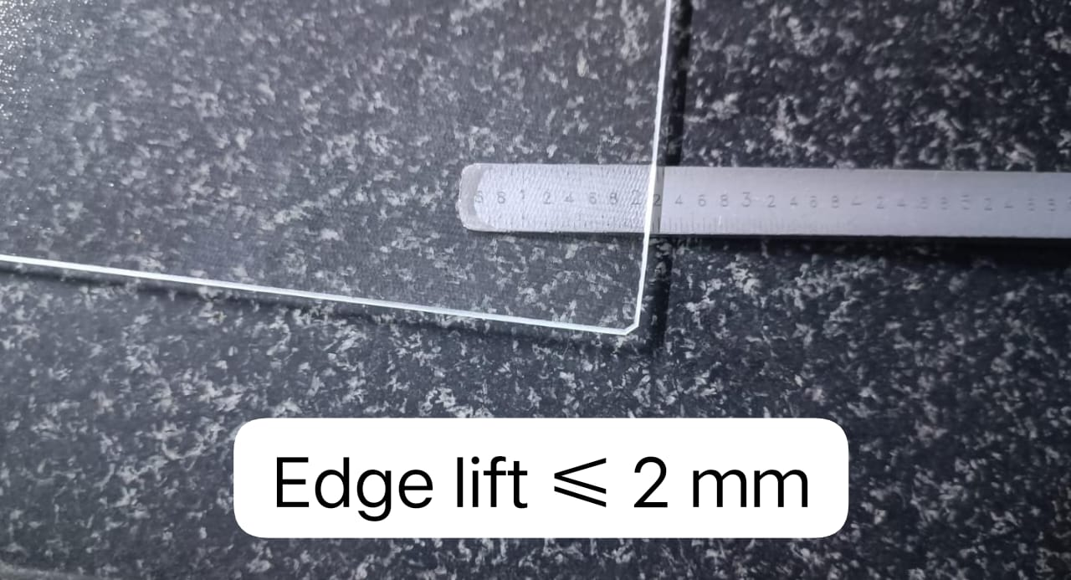
- Fragment Test |  |  |  |  |  | 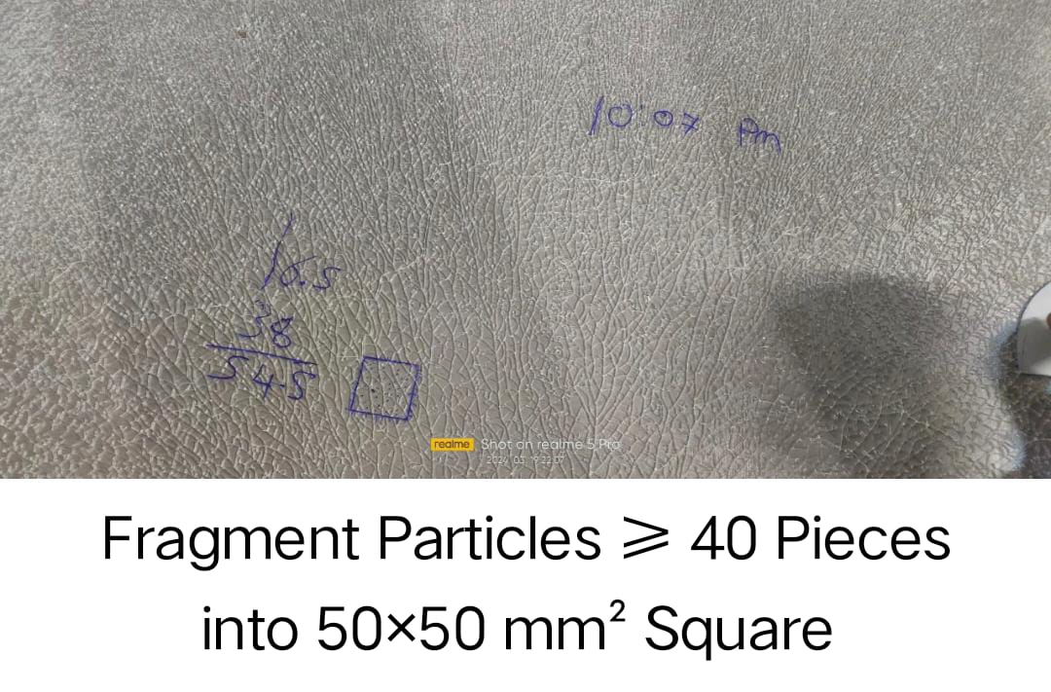
- Local Bow |  |  |  |  |  | 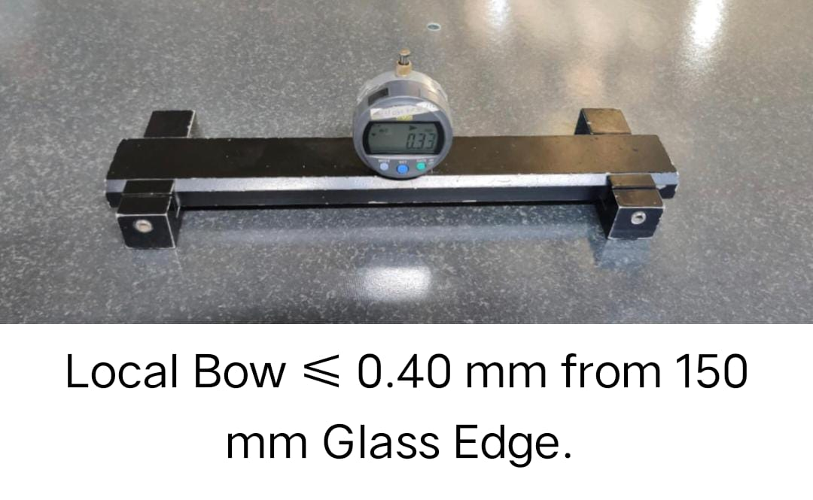
7.1.8 If Machine all condition ok found and If glass all Quality Parameter meets with Standard of Quality, then start the line.

7.2 Tools and equipment required in Emergency condition.
IF Any Type of Emergency Condition Occurred Like Glass Jam into Furnace, Conveyor Rollers Stop, Sensor Sequence Fail So Glass Stop on Conveyor Table, Power Trip, Blower Frequency Trip at that time Before stopping the machine the following tools should be available.  - Glass Breakage Tools |  |  |  |  |  | 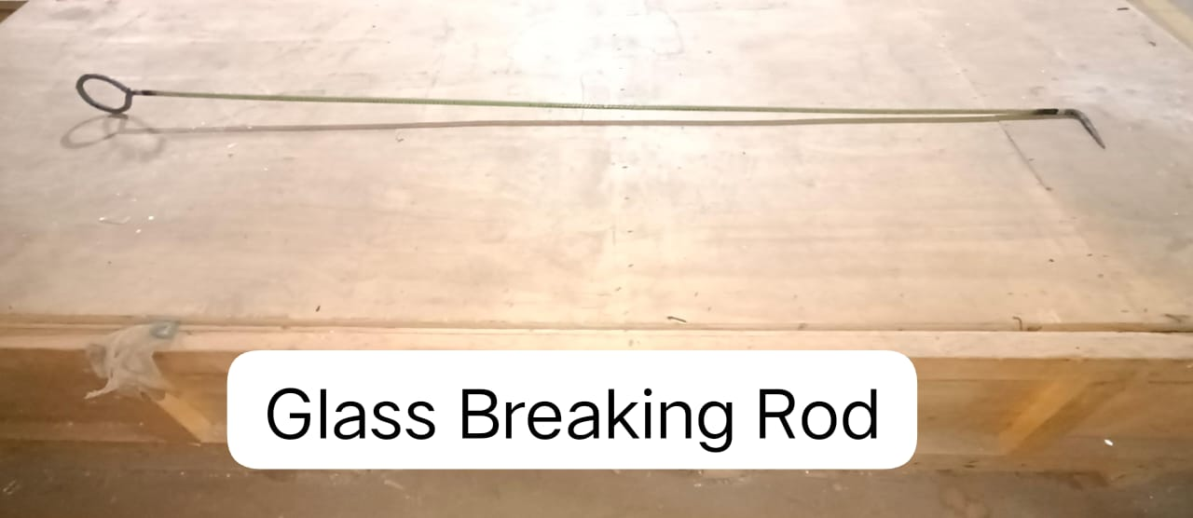
- Cullet Remover Spade |  |  |  |  |  | 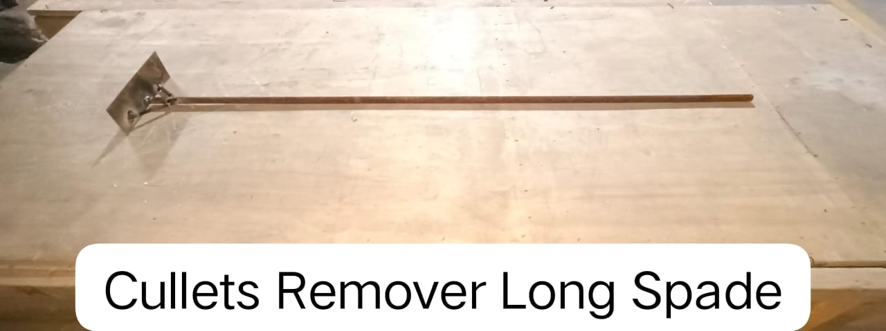
- Ceramic Roller Remover Slider |  |  |  |  |  | 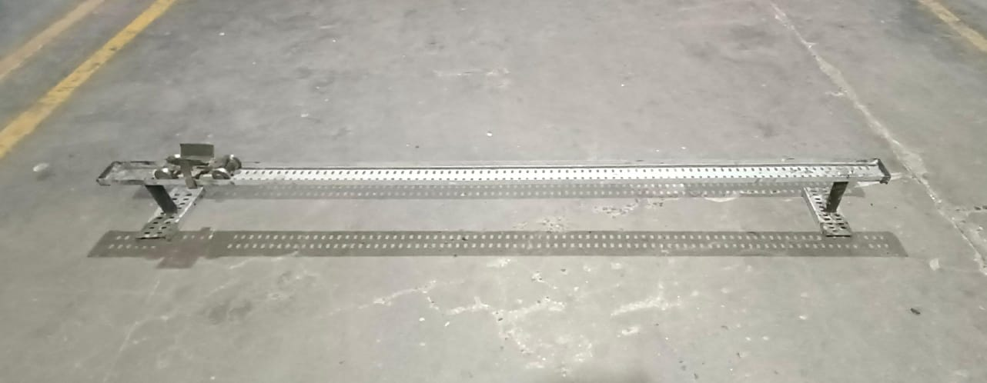
- Cullet Remover Spade
- Heat Resistance Hand Gloves |  |  |  |  |  | 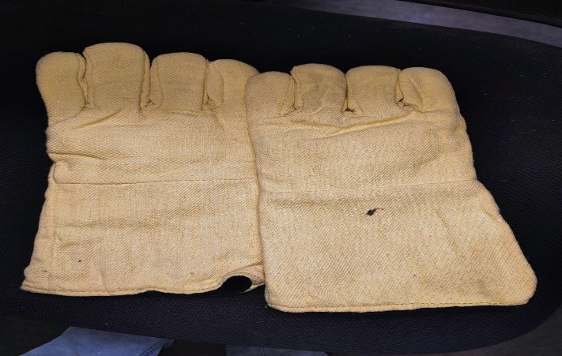
- Fire Extinguisher |  |  |  |  |  | 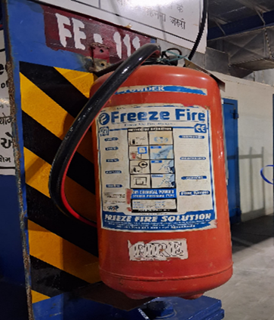
7.3 Prevention & Detection
7.3.1 All Quality Standard for Glass Should be required ok
7.3.2 Continues monitoring the HMI for any alarm for power fail or drive fail
7.4 Controls Related to EHS
7.4.1 PPE MATRIX
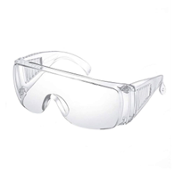 |  | 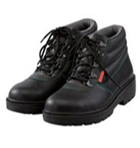 |  |  |  |  | 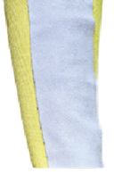
Goggles |  | Safety Shoes |  | Hand Gloves |  |  | Arm Guard
7.4.2 Broken glass needs to dispose of in cullet bin without contamination of foreign material
8.0 EHS Compliance Obligations
8.1 NA
9.0 Possible deviation & Impacts |  |  |  |  |  | 10.0 Proposed actions
9.1 If prompt action is not taken in case of General Bow, Edge lift, Local bow, fragment Practical the Glass Quality will be impacted |  |  |  |  |  | 10.1 Check the Machine Settings, Process Parameters, Blower Pressure, Condition of the sensor etc., and take appropriate action
11. Reference documented information
11.1 Tempering -1 operation record and process report – TEMP/L4/002
11.1 Work instruction of TL1 – TEMP/L3/005
12. Revision History
Revision No. | Date |  | Description of changes
00 | 12.02.2020 |  | Initial release.
01 | 04.10.2025 |  | Format standardized, revision history added, step correction done.

